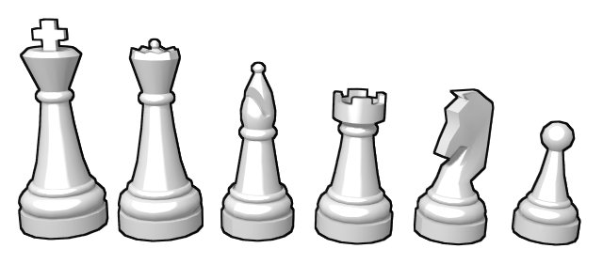Chess Club 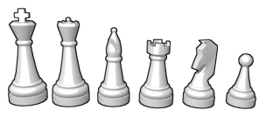
Autumn Term 2023. St Dunstan’s, years 2&3.
Mondays after school until 4.20 p.m. 18th September to 5th December.

Dear Parent / Carer,

- Newcomers to chess learn the names of pieces and how they move.
- Children build on their previous chess experience.
- More experienced players learn and have fun by playing games.
There are numerous sites you can practise on-line e.g. https://lichess.org/
Using the Internet always carries the usual cautionary warnings.
If you wish to join, please return your form to the office marked ‘chess – Mr Buckley’ by 15th September, and choose one of the two payment options. Places will be given on a first come first served basis. Anyone turning up for the first session will be accommodated. If you are not successful in obtaining a place for the full term, I will contact you before session 2. If you do not wish to join the waiting list, your chess fee will be returned. Space permitting, pupils can join late during the term at a cost of £11 per week.
Graeme Buckley, International Master; GNBuckley@aol.com, 020 8642 5239
----------------------------------------------------------------------------------------------------------------------------
Autumn Term 2023 – Beginner chess (to return to the school office).
I wish to enrol my child in chess club, and I have paid £82 (£72 if by 15.9.23) by:

*Cheque (Payable to ‘Play Chess’) □ *Electronic transfer □ *(please tick as appropriate).

Electronic transfer: please put the reference as ST.D. + surname of child + initial, and return the form below with payment sent to account: sort code: 30-98-36, number: 29982868, name: PLAY CHESS.

NAME OF CHILD ………………………………………………….……........ YEAR (in Sept) …………….…

E-MAIL …………………………………………………………….…… TEL..…………………………….……

SIGNATURE …………………………………………………………… DATE………………………

Please tick the box if you give your consent (and you haven't already given it) for your email address to be shared with other St Dunstan's chess families in order to make arrangements for chess events. □

