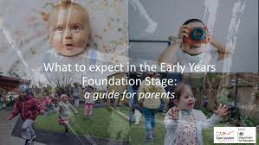

Please refer to this useful guide for parents and carers of children from birth to five years old. It will help you find out more about your child’s learning and development in the EYFS.

https://foundationyears.org.uk/wp-content/uploads/2021/09/What-to-expect-in-the-EYFS-complete-FINAL-16.09-compressed.pdf

