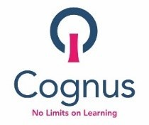

Transfer to Secondary School 2022 – Covid 19 Pandemic

The attached information has been prepared to help you with making your application to Transfer to Secondary School in September 2022.

We understand that in these exceptional times you may have more questions and concerns regarding how the current situation will affect your application. Please be assured that the Cognus School Admissions Team and Primary and Secondary Schools in Sutton are working hard to try to bring you the most up to date information, but as the situation continues to evolve there may be some changes to the information we have provided.

The open evening dates provided are provisional at the moment and subject to change.

Any updates to this information will be posted on the school admissions pages of Sutton’s website www.sutton.gov.uk/admissions and on the individual school’s websites. We would strongly recommend that you check the websites regularly for updates.

If you require more information please contact Sutton’s school admissions team at suttonadmissions@cognus.org.uk telephone 0208 770 5000 or contact the Secondary schools directly.

