Starting School September 2024
For children born between 1 September 2019 and 31 August 2020

Applying For a Starting School Place
All parents and carers who wish their child to attend a primary/infant school must make an application through their home local authority from 1 September 2023 but before midnight on 15 January 2024. To do this, please visit the Sutton website at www.sutton.gov.uk/admissions

This sheet is a summary of the information you need to apply for starting school. We recommend you read the full guidance at www.sutton.gov.uk/admissions before applying.

- No Priority is given to children attending the school nursery.

- If you already have a sibling in your preferred school there is no automatic placement, you must still make an online application.

Visiting schools
We recommend you visit schools to understand transport routes and school facilities, and to hear from staff about the school achievements and plans for the future. Please check school websites for possible open day dates or for details of how to contact them. The map below shows the location of Sutton schools. You should also consider those local to you in neighbouring boroughs.

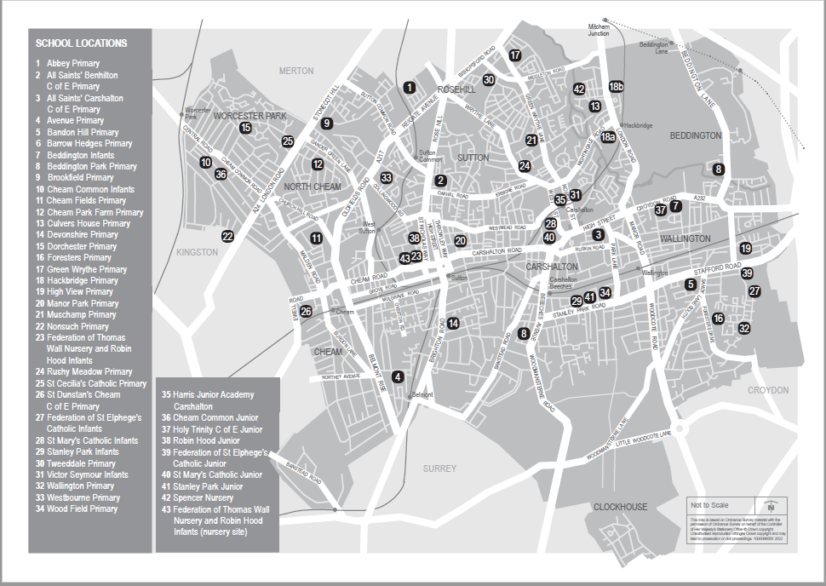
Supplementary Forms
Some schools may ask for a supplementary form to be completed. The online application will advise you if this is the case, or you can check the online booklet at www.sutton.gov.uk/admissions.
Your child
- We need your child’s legal full name and date of birth. An application can only be made from a single address and only a single application made for each child.
- The address used in an application must be that where an adult or adults with legal responsibility for the child live. Address information will be checked.
- These checks may be made using council systems, agencies, fraud departments, other education settings, or other resources available to us. Applicants may also be asked to provide additional evidence to support their application. Please refer to the Starting School booklet (www.sutton.gov.uk/admissions) for information about the address to be used on your application.
- Indicate if your child has an Education Health and Care Plan. If ‘yes’ you should contact your EHCP co ordinator to follow a different application process

Your primary school preferences
- You may name up to six schools on the form. The schools do not have to be in Sutton, they can be in any borough.
- Please name any sibling(s). You should check the admissions criteria for the school concerned as sibling rules may not be the same for each school.
- You may state a reason for your preference if you wish.
- Medical or social priority (where a school has this criteria) will not be considered unless supported by professionally written evidence which should be attached to the online application.
- A number of schools give priority to children of staff, you must tick the box to confirm this eligibility and complete any required forms.
How places are allocated
- Each admissions authority will have a set of criteria by which applicants are ranked and places offered. These are only relevant if the school has more applicants than places.
- Schools are not informed of your preference order, and rank applications based solely on their published criteria. The criteria for Sutton schools can be found at www.sutton.gov.uk/admissions
- Some schools will give higher priority within some of their criteria for those who live nearest to the school. You can find out information about where your local schools are and how far these schools have offered to in recent years by using the distance checker (past distances can be used as a guide only) available at www.sutton.gov.uk/admissions

We recommend you visit www.sutton.gov.uk/admissions to view the admissions booklet and apply online because:
- you will receive earlier notification of the result of your application
- no forms will get lost in the post
- the data validation system prevents you from giving incorrect school names or numbers
- you will receive an instant email confirmation of your completed application once you have submitted it
- it is a safe and secure password operated system
- you can amend your application right up to the closing date
Key Dates
From 1 September 2023 | Online applications can be made.
September 2023 to January 2024 | Please visit school websites for more information details on visiting or contact them to book an appointment.
15 January 2024 | Closing date for online applications or paper application forms. After this date your application will be considered as late.
8 February 2024 | Latest date that an application that is late for good reason can be accepted. Reasons and evidence must be presented with the application by this date.
16 April 2024 | Applicants who use a paper form, and if we do not hold a valid email address will be posted a letter to their home address.
Evening of 16 April 2024 | Results available for applications submitted online.
May to September 2024 | Additional offers made as vacancies occur.
June to July 2024 | Admissions appeals.
For all enquiries relating to the school admissions process, please contact the Cognus School Admissions Team on: suttonadmissions@cognus.org.uk Postal Address: Cognus School Admissions Team, Cantium House, Railway Approach, Wallington, SM6 0DZ. www.sutton.gov.uk/admissions

