***SATs information for Parents 2024***

**End of KS2 SATs Timetable 2024**

| **Day** | **Test - all take place in the morning** |
| --- | --- |
| Monday 13th May | \*English grammar, punctuation and Spelling Paper 1: questions (45 minutes)  \*English grammar, punctuation and Spelling Paper 2: spelling (untimed but general guidance of approximately 15 minutes) |
| Tuesday 14th May | \*English reading  (1 hour) |
| Wednesday 15th May | \*Mathematics Paper 1: arithmetic  (30 minutes – 36 questions)  \*Mathematics Paper 2: reasoning  (40 minutes) |
| Thursday 16th May | \*Mathematics Paper 3: reasoning  (40 minutes) |

NB: English writing does not have a designated test – it is an ongoing assessment throughout the year.

**How are the results reported?**

Scaled Scores

* Test scores are reported to parents as ‘scaled scores’.
* It is normally the case that a scaled score of 100 represents the ‘national standard’. Each pupil’s raw test score will therefore be converted into a score on the scale, either at, above or below 100.
* Using the scaled score, the lowest a child can score is 80, with the highest being 120. A child who achieves the ‘national standard’ (a score of 100) will be judged to have demonstrated sufficient knowledge in the areas assessed by the tests.
* In previous years, 80-99 has been below age related expectation; 100-109 has been at the expected and 110-120 has been working at greater depth.
* Each pupil receives:

• a raw score (number of raw marks awarded);

• a scaled score in each tested subject;

• confirmation of whether or not they attained the national standard. The results do not state that a score of 110 or above is working at greater depth, as this is not officially decided until after the results have been sent out.

* The Reading, Grammar, punctuation and spelling (GPS) and Mathematics papers are all marked externally.
* English writing is assessed by the class teachers, following training. Every year, around 25% of schools are moderated to ensure that the judgements being made are deemed correct.

The results

* You will receive your child’s results with their report at the end of the year.
* It will contain both teacher assessment results and test results. They will tell you whether your child has met the expected standard or not.
* Test results will also be given as scaled scores.
* High schools will also receive these results.

How we support your children at school

* We don’t want the children to become anxious but we do have to talk about the tests and prepare them. Some children want to know all there is to know about the process and others prefer to hear less. We aim to strike a happy medium, encouraging the children to do their best and to be proud of the effort they put in.
* All children are challenged within the curriculum in a way that is appropriate to their ability. No child is tested on curriculum content that is above the Year 6 National Curriculum requirements. The children are challenged to dive deeper with their understanding in order to widen their skills, thinking and strategies.
* There will be some pupils who qualify for additional time (25% more minutes), rest breaks, a reader, a scribe or to have the test papers copied onto coloured paper or enlarged. There are clear criteria for this and, as class teachers, alongside Mrs Cordery and Mrs Porter, we will discuss and apply for certain adaptations for the relevant pupils.

Mathematics

* Children will sit three tests: paper 1, paper 2 and paper 3.
* Paper 1 is for arithmetic lasting for 30 minutes, covering calculation methods for all operations, including use of fractions, percentages and decimals. Questions gradually increase in difficulty.
* Papers 2 and 3 cover problem solving and reasoning, each lasting for 40 minutes. Pupils will still require calculation skills but will need to answer questions in context and decide what is required to find a solution.

Maths - Arithmetic

* 36 questions in 30 minutes.
* Each question has squared paper space to do jottings or formal calculations where necessary.
* Some questions don’t need anything to be written – children need to be confident with mental strategies e.g. multiplying and dividing by 10, 100, 1000.
* Knowledge of number and place value at speed.
* Questions get progressively harder.
* 4 questions near the end are worth 2 marks: 2 long division, 2 long multiplication. The children are expected to use the formal written method for these. Further examples of the formal written methods can be found [here](https://assets.publishing.service.gov.uk/government/uploads/system/uploads/attachment_data/file/238967/Mathematics_Appendix_1.pdf).

Formal method of long division

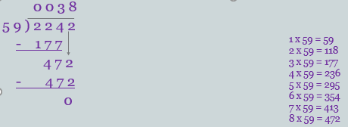

NB: Mark scheme says that **short division method can be used** but there must be clear evidence of carrying correctly to get both marks.

Formal method of multiplication

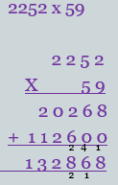

Maths – Reasoning (example questions)

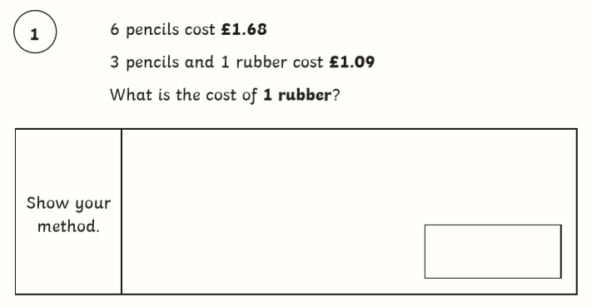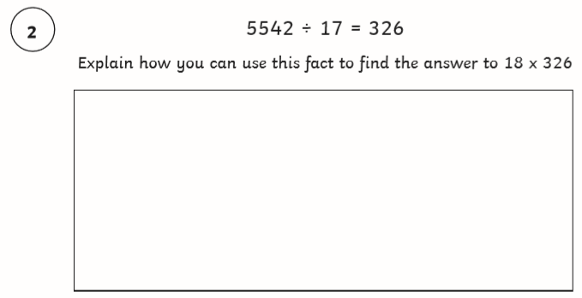

Maths – top tips

* Ensure the final answer goes in the box with any unit of measure not already written in the box.
* Correct formation of numbers – if a 4 looks like a 9 or a 0 looks like a 6 it runs the risk of being marked as incorrect.
* Know number facts e.g. multiplying by 100 makes the number move 2 places larger (need to know place value headings); there are 1000g in 1kg; knowing that sum means to add and product means to multiply; a right angle is 90⁰, prime numbers; square numbers; how many days in each month …
* Know the meaning of key vocabulary <http://www.amathsdictionaryforkids.com/>
* Check they have actually answered the question e.g. write the numbers in descending order.
* If it says ‘Show your method’, show your method!
* Questions that involve ‘Explain your method’ can be a straightforward number calculation to show the answer or a written explanation with number examples as back up.

How to help your child with maths

* Play times tables games – log in to Times Tables Rock Stars.
* Play mental maths games including counting in different amounts, forwards and backwards.
* Encourage opportunities for telling the time.
* Encourage opportunities for counting coins and money; finding amounts or calculating change when shopping.
* Look for numbers on street signs, car registrations and anywhere else!
* Look for examples of 2D and 3D shapes around the home.
* Identify, weigh or measure quantities and amounts in the kitchen or in recipes.
* Play games involving numbers or logic, such as dominoes, card games, darts, draughts and chess.

Writing

* Writing will be assessed internally by the class teachers. Although the children’s ‘published’ writing will form the basis of the writing judgements,every piece of written work can be used as evidence. e.g. a set of bullet points correctly used in a science method, retelling a Bible story in RE and using a wide variety of punctuation within the piece of writing in any subject.

Writing framework

* Using a detailed writing framework allows us, and the children themselves, to keep track of how frequently children are using certain skills.
* The expectation is that, across a range of writing, the children demonstrate each item on the list.
* Any gaps identified as ‘cannot do it’ or ‘has a weakness in it’ are addressed with the children on an individual basis.
* The children are able to take greater ownership of their successes and areas for development.
* Each year, approximately 25% of schools in the Borough are selected for external moderation of the writing assessments and the results we submit.

How to help your child with writing

* Practise spelling words from the Year 3-4 and Year 5-6 spelling lists – make it fun!
* Encourage opportunities for writing such as letters to family or friends, shopping lists, notes or reminders, stories and poems.
* Write together – be a good role model for writing.
* Encourage use of a dictionary to check spelling and a thesaurus to find synonyms and expand vocabulary.
* Remember that good readers become good writers! Identify good writing features when reading (e.g. vocabulary, sentence structure and punctuation).
* Praise and encourage, even for small successes!

Examples of nationally agreed writing standards can be found [here](https://www.gov.uk/government/publications/2018-teacher-assessment-exemplification-ks2-english-writing).

Writing framework

|  | **KS2 Teacher Assessment for Writing** | | | |
| --- | --- | --- | --- | --- |
|  | **Working towards the expected standard - I can already do these and I am still using them in my work:** | | | |
| 1 | Write for a range of purposes. | | | |
| 2 | Use paragraphs to organise ideas. | | | |
| 3 | In narratives, describe settings. | | | |
| 4 | In narratives, describe characters. | | | |
| 5 | In non-narrative writing, use simple devices to structure the writing and support the reader (e.g. headings, sub-headings,  bullet points). | | | |
| 6 | Use mostly correctly | | Capital letters | |
| Full stops | |
| Question marks | |
| Commas for lists | |
| Apostrophes for contraction | |
| 7 | Spell correctly **most** words from the Year 3 and 4 spelling list. | | | |
| 8 | Spell correctly **some** words from the Year 5 and 6 spelling list. | | | |
| 9 | Write legibly. | | | |
|  |  | | | |
|  | **Working at the expected standard - I will be at the expected standard if I consistently and accurately show these in my work:** | | | |
|  |  | | | |
| 10 | Write effectively for a range of purposes and audiences, selecting language that shows good awareness of the reader  (e.g. use first person in a diary; direct address in instructions and persuasive writing). | | | |
| 11 | In narratives, describe settings. | | | |
| 12 | In narratives, describe characters. | | | |
| 13 | In narratives, describe atmosphere. | | | |
| 14 | Integrate dialogue in narratives to convey character and advance the action. | | | |
| 15 | Select vocabulary and grammatical structures that reflect what the writing requires, doing this mostly appropriately (e.g. using contracted  forms in dialogue in narratives; using passive verbs to affect how information is presented; using modal verbs to suggest degrees of possibility). | | | |
| 16 | Use a range of devices to build cohesion (e.g. conjunctions, adverbials of time and place, pronouns, synonyms) within and across  paragraphs. | | | |
| 17 | Use verb tenses consistently and correctly throughout their writing. | | | |
| 18 | Use the range of punctuation taught at KS2 **mostly** correctly | Capital letters, full stops, question marks, exclamation marks. | | |
| Commas: in lists, after fronted adverbials, for parenthesis and for clarity. | | |
| Apostrophes for possession and contraction. | | |
| Inverted commas and other punctuation to indicate direct speech. | | |
| Brackets, dashes, hyphens, colons and semicolons. | | |
| 19 | Spell correctly **most** words from the Year 5 and 6 spelling list. | | | |
| 20 | Use a dictionary to check the spelling of uncommon or more ambitious vocabulary. | | | |
| 21 | Maintain legibility in joined handwriting when writing at speed. | | | |
|  |  | | | |
|  | **Working at greater depth within the expected standard - I will be at the greater depth if I consistently and accurately show these in my work:** | | | |
| 22 | Write effectively for a range of purposes and audiences, selecting the appropriate form. | | | |
| 23 | Draw independently on what has been read as a model for their own writing. | | | |
| 24 | Distinguish between the language of speech and writing and choose the appropriate register. | | | |
| 25 | Exercise an assured and conscious control over levels of formality, particularly through choice of grammar and vocabulary. | | | |
| 26 | Use the range of punctuation taught at KS2 **correctly** | | | Capital letters, full stops, question marks, exclamation marks. |
| Commas: in lists, after fronted adverbials, for parenthesis and for clarity. |
| Apostrophes for possession and contraction. |
| Inverted commas and other punctuation to indicate direct speech. |
| Brackets, dashes, hyphens, colons and semicolons. |
| 27 | Where necessary, use punctuation precisely to enhance meaning and avoid ambiguity. | | | |

Reading

* The reading test consists of a single test paper with three unrelated reading texts. Children are given 60 minutes in total, which includes reading the texts and answering the questions.
* A total of 50 marks are available.
* Questions are designed to assess the comprehension and understanding of a child’s reading.
* During the reading paper, a child’s inference and deduction skills are thoroughly tested. They will also be expected to answer questions on authorial choices: explaining why an author has chosen to use particular vocabulary, grammar and text features.
* Some questions are multiple choice, others require short answers and some require an extended response or explanation.

Reading sample questions

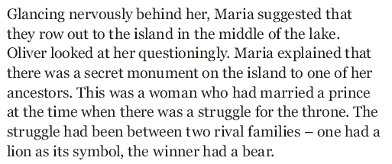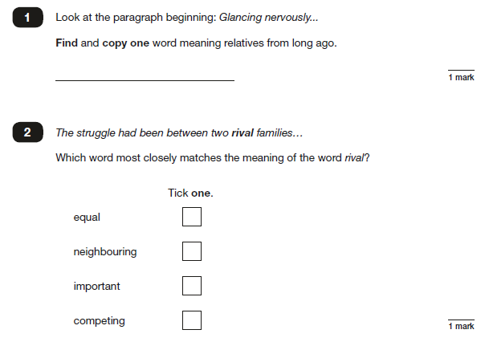

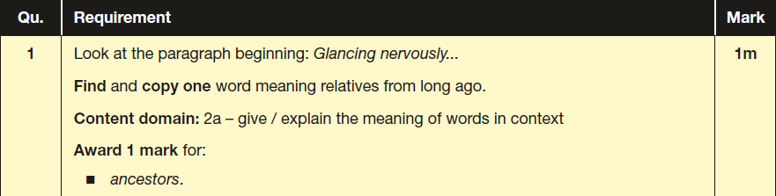

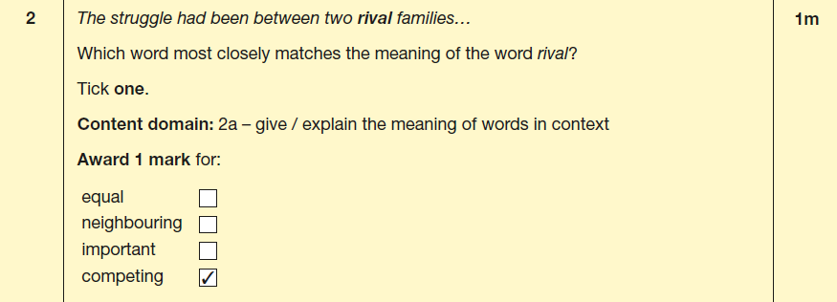

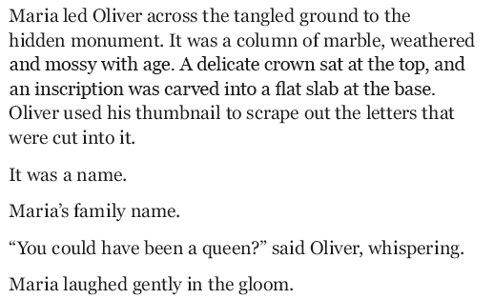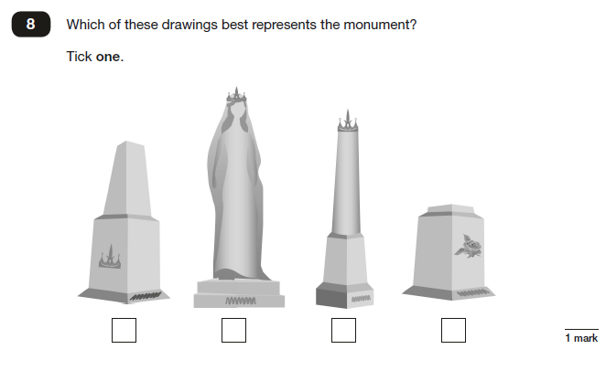

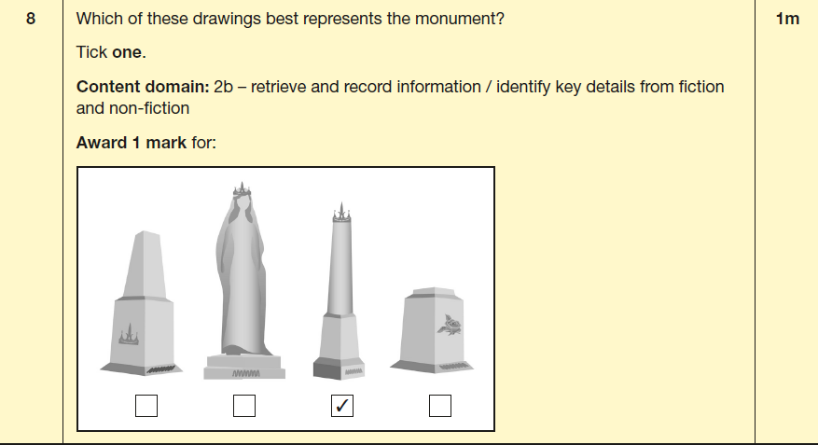

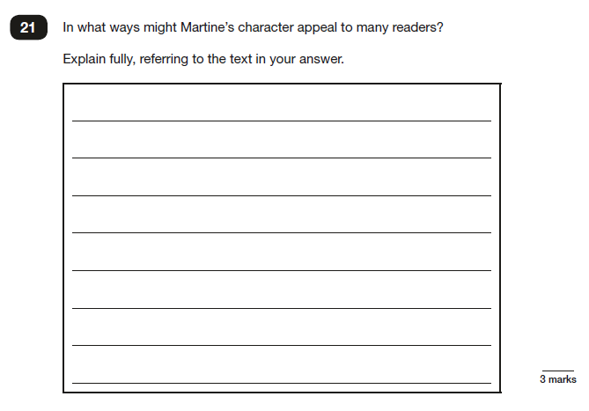

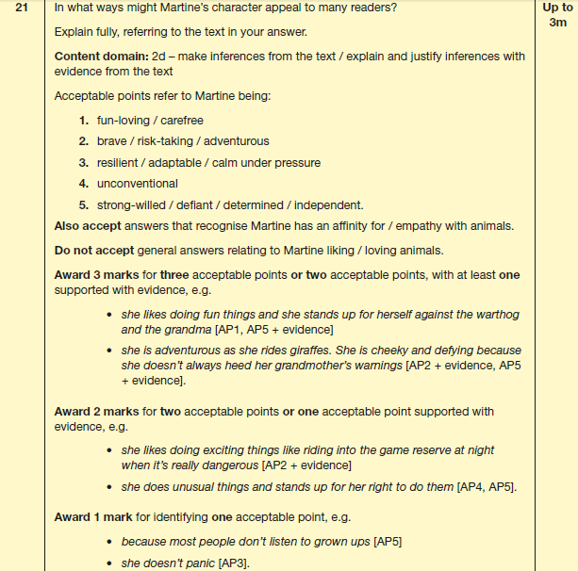

How to support your child with reading

* Listening to your child read can take many forms.
* First and foremost, focus on developing an enjoyment and love of reading.
* Enjoy stories together – reading stories to your child at KS1 and KS2 is equally as important as listening to your child read.
* Read a little at a time but often, rather than rarely but for long periods of time!
* Talk about the story before, during and afterwards – discuss the plot, the characters, their feelings and actions, how it makes you feel, predict what will happen and encourage your child to have their own opinions.
* Look up definitions of words together – you could use a dictionary, the internet or an app on a phone or tablet.
* All reading is valuable – it doesn’t have to be just stories. Reading can involve anything: fiction, non-fiction, poetry, newspapers, magazines, football programmes and TV guides.
* Visit the local library - it’s free!

Grammar, Punctuation and Spelling (GPS)

* A spelling test is administered containing 20 words, which lasts approximately 15 minutes. They are tested on a range of the many spelling patterns they have learnt through KS1 and KS2, as well as the words from the Statutory Spelling lists. All lists can be found here: [Spelling curriculum](https://assets.publishing.service.gov.uk/government/uploads/system/uploads/attachment_data/file/239784/English_Appendix_1_-_Spelling.pdf)
* A separate test is given on grammar, punctuation and vocabulary.
* This test lasts for 45 minutes and requires short answer questions including some multiple choice.
* Marks for these two tests are added together to give a total for grammar, punctuation and spelling.

GPS sample questions

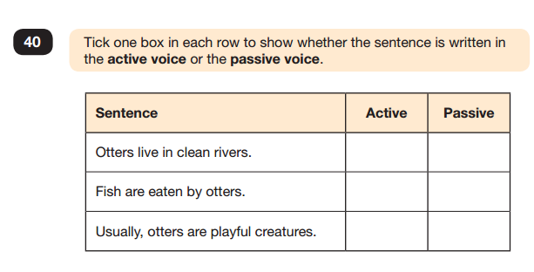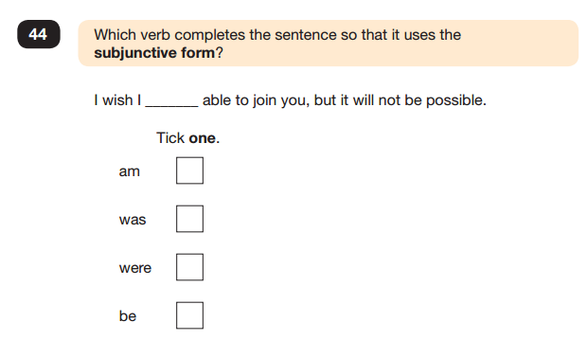

C:\Users\teach51.STDUNSTANS.002\AppData\Local\Microsoft\Windows\Temporary Internet Files\Content.IE5\V8HO8B9U\Check_mark_23x20_02.svg[1].png

C:\Users\teach51.STDUNSTANS.002\AppData\Local\Microsoft\Windows\Temporary Internet Files\Content.IE5\V8HO8B9U\Check_mark_23x20_02.svg[1].pngC:\Users\teach51.STDUNSTANS.002\AppData\Local\Microsoft\Windows\Temporary Internet Files\Content.IE5\V8HO8B9U\Check_mark_23x20_02.svg[1].pngC:\Users\teach51.STDUNSTANS.002\AppData\Local\Microsoft\Windows\Temporary Internet Files\Content.IE5\V8HO8B9U\Check_mark_23x20_02.svg[1].png

How to help your child with GPS

* Ensure they are writing and placing punctuation accurately. A semi-colon in the correct place but not quite placed correctly on the line will be marked as incorrect.
* Be familiar with key vocabulary e.g. passive voice. A **glossary of terms** from the English national curriculum can be found [here](https://assets.publishing.service.gov.uk/government/uploads/system/uploads/attachment_data/file/244216/English_Glossary.pdf).
* Help them to follow instructions e.g tick one / two.

Liaising with High Schools

* The results of the SATs tests will be sent to your child’s secondary school.
* Prior to this, the Year 6 teachers will have given the secondary schools a teacher assessment for reading, writing and maths.
* In the summer term, the Year 6 teachers will discuss each of the children with the relevant Year 7 team, so that the transition from St Dunstan’s to their secondary school is as smooth as it can be.
* The children usually have the opportunity to meet with members of the Year 7 team at their secondary school either through the Year 7 staff visiting them at St Dunstan’s or through induction days at the secondary school, or both.